ECE 874 - Spring 2013 **Test 4 In-Class Component** Name _____________________

(80 points total)

1. (10 pts) Given the interconnection of *H1* and *H2* shown. Estimate the conditions on *K* for the system to be input-output stable? (the magnitude plot is in dB, 20log(x))

|  |  |
| --- | --- |
| ~-15db  K  0.1  *H2* | *H1* |



1. (10 pts, about 1 pt each) Circle the correct answer.

|  |  |  |  |
| --- | --- | --- | --- |
|  |  |  |  |

1. (10) Is the system *H* casual? Briefly explain why or why not.

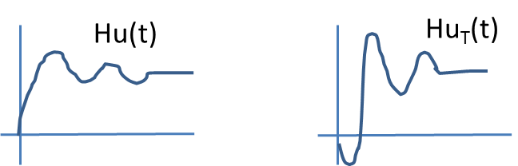 

4 (10pts) You have come to the point in your analysis where you find:

,

finish the analysis by showing  is negative semi-definite in either *x* or *s* (your choice). What are the conditions on *k1* and *k2*?







1. (15pts) Design a tracking controller, *u(t),* for the system:  The desired trajectory, *xd*, and the first two derivatives exist and are bounded.



Prove that the controller will work and that all signals remain bounded.



